**Industrial Visit Report**

**Industrial Visit to Doordarshan Kendra, Worli, Mumbai**

**Date of Visit:** October 24, 2024

**Location:** Doordarshan Kendra, Worli, Mumbai

**Organized by:** Sardar Patel Institute of Technology, Mumbai

**Participants:** Students and Faculty from the Consumer Electronics Course.

### 1. Introduction

The industrial visit to Doordarshan Kendra, Worli, Mumbai, was organized to enrich the students' understanding of the technical and operational aspects of a television broadcasting station. As a pioneering entity in Indian broadcasting, Doordarshan Kendra has been instrumental in delivering information, entertainment, and education to millions across the nation. By visiting such a well-established media organization, students from the Consumer Electronics course were given a rare opportunity to observe the behind-the-scenes processes and technologies that power live television broadcasts, recorded shows, and satellite transmissions.

The visit was particularly relevant for the students' academic curriculum, as it allowed them to witness firsthand the integration of cutting-edge electronics, broadcast engineering, and media technology within a professional environment. Through structured tours and demonstrations, students learned about the various components of broadcasting, such as video and audio processing, production control, signal transmission, and digital recording. They also gained exposure to advanced equipment like 4K cameras, LED lighting, digital mixers, and teleprompters, all of which are crucial in today’s broadcast industry.

Moreover, this visit encouraged students to engage with industry professionals, enabling them to ask questions, clarify technical concepts, and understand the real-world application of the theoretical knowledge they acquire in the classroom. Through these interactions, students developed a broader perspective on the role of consumer electronics in media and communication, gained insights into professional practices, and learned about emerging trends and challenges in the broadcast industry. This experience helped to contextualize their studies, enhancing their comprehension of the field and preparing them for future careers in media technology and electronics.

**2. Objectives of the Visit**

* **To gain practical knowledge about broadcast technology and media operations**: The visit aimed to provide students with a firsthand look at the technical aspects of television broadcasting, including the equipment, processes, and systems used in real-world media production.
* **To understand the operational processes in a real-world setting**: Observing the day-to-day operations at Doordarshan Kendra allowed students to see how theoretical concepts in consumer electronics and media technology are applied in an industrial setting.
* **To interact with industry professionals and gain insights**: By engaging with experienced professionals, students could gain insights into industry standards, workflows, and the challenges faced in the broadcasting field, enhancing their learning and understanding of the practical applications of their coursework.
* **To explore the integration of modern technology in traditional media**: Through exposure to technologies such as LED lighting, 4K cameras, digital mixers, and RF and lapel microphones, students learned about the advancements that are transforming the media industry and the technical requirements for maintaining broadcast quality.
* **To broaden understanding of the role of consumer electronics in media production**: The visit aimed to illustrate the significance of consumer electronics in the media industry, helping students appreciate the interconnectedness of electronics, audio-visual technology, and media communication.

**3. Itinerary**

* **10:00 AM** – Arrival at Doordarshan Kendra, Worli, Mumbai, and initial briefing
* **10:15 AM - 12:15 PM** – Tour of the Studio Section
  + Visit to studios (A1, B1, C1), Production Control Room, Camera Control Unit, and Master Switching Room
* **12:15 PM - 2:00 PM** – Lunch Break
* **2:00 PM - 4:30 PM** – Tour of the Transmission Section
  + Overview of signal encoding, modulation, up-conversion processes, and satellite transmission setup
* **4:30 PM** – Departure

### 4. Company/Industry Overview

**Doordarshan Kendra, Worli, Mumbai** is one of the most established and pivotal broadcasting centers under Doordarshan, India’s national television network managed by Prasar Bharati. Primarily catering to **DD Sahyadri**, a regional channel that broadcasts in Marathi, Doordarshan Kendra, Mumbai plays a vital role in reaching Marathi-speaking audiences across Maharashtra and beyond.

Operating on a **24x7 basis**, Doordarshan Kendra adheres to a predefined schedule that includes a diverse lineup of live broadcasts, pre-recorded shows, and news segments (locally known as Batmya) throughout the day. This round-the-clock service delivers a mix of content aimed at educating, entertaining, and informing viewers. The programming includes cultural shows, entertainment, educational segments, and local news, addressing the needs of a broad audience base.

The **Studio Section** at Doordarshan Kendra is home to three primary studios (A1, B1, and C1), each equipped with Grass Valley 4K cameras, professional LED lighting, acoustic setups, and digital mixers. These studios produce and broadcast a variety of programs, utilizing state-of-the-art production equipment such as vision mixers, audio mixers, and teleprompters to ensure high-quality broadcasts. The **Production Control Room** manages the output from multiple cameras, adjusting video effects, sound levels, and background scenes using an LED wall and color correction tools.

The **Transmission Section**, located approximately 200 meters from the main studio area, handles the final transmission process. This section encodes the video feed, performs modulation and up-conversion, and transmits it via satellite using a time-division multiplexer and RF signals. The transmitted signal ensures that DD Sahyadri's programming reaches viewers effectively across a wide geographical area.

Doordarshan Kendra's integration of traditional broadcast methods with modern technology provides a comprehensive learning experience for students, offering a glimpse into the rigorous operational standards and real-world applications of consumer electronics and broadcast engineering within a high-demand, live broadcast environment.

### 5. Observations

During the visit to Doordarshan Kendra, I observed the intricate operations involved in broadcasting and the advanced technology employed to ensure seamless production and transmission.

* **Studio Layout and Equipment**: The studio section, consisting of three studios (A1, B1, and C1), was equipped with Grass Valley 4K cameras that, despite their 4K capability, are primarily used for HD broadcasting. The cameras captured high-quality visuals which were further enhanced using **color temperature correction filters** to adjust lighting as needed. The studios were well-lit with LED lights, and perforated sheets were used for sound acoustics, minimizing echo and enhancing audio quality.
* **Production Control Room**: The production control room displayed feeds from six cameras simultaneously, allowing technicians to switch between different shots for dynamic, multi-angle coverage. A **vision mixer** was used for video effects, color grading, and transitions, while the **digital audio mixer** managed multiple audio sources and removed noise, enabling professional-quality surround sound. I observed the use of **RF and lapel microphones**, with lapel mics employed for specific scenarios, showing the importance of audio versatility in production.
* **Camera Control Unit**: The camera control unit allowed technicians to monitor and adjust various camera settings, including skin tone correction, color temperature, and intensity, based on scene requirements. I noted the use of **Blu-ray recorders** for recording feeds, which provide the advantage of data recovery even if parts of the disc are corrupted, ensuring data security for recorded content.
* **Master Switching Room and Routing**: This room consolidated all outputs from different rooms, where a router was used to select which video feeds were transmitted live. The process highlighted the importance of quick decision-making in live broadcast environments.
* **Playback Room**: In this area, I saw how live recordings were handled and the process of monitoring downlink and uplink footages. The final signal, known as the **PGM (program)** feed, was prepared for broadcast, showcasing the final step before transmission.
* **Transmission Section**: Located at a distance from the studio, the transmission section received the final feed via optical fiber. The signal underwent **encoding, time-division multiplexing, modulation,** and **up-conversion** before being transformed into RF and transmitted to a satellite. This complex process ensured a stable broadcast signal, demonstrating the technical aspects of large-scale broadcasting.

### 6. Key Takeaways

* **Understanding Broadcast Workflow**: I gained a comprehensive understanding of the workflow involved in broadcasting, from studio recording to signal transmission. Observing the studio and transmission sections provided a holistic view of how live shows, recorded programs, and news are seamlessly integrated into a 24x7 schedule.
* **Exposure to Professional Equipment**: The visit offered hands-on exposure to advanced broadcasting equipment like cameras, LED lighting systems, vision and audio mixers, and Blu-ray recorders. Learning about the features and functionality of this equipment helped students appreciate the technical precision required in high-quality production environments.
* **Insights into Signal Transmission**: The transmission section provided a deeper understanding of signal processing and broadcasting technology. Concepts like **encoding, modulation, time-division multiplexing, and up-conversion** were practically demonstrated, showing students the stages involved in converting a studio feed into a satellite-ready signal.
* **Importance of Audio-Visual Quality Control**: Observing the production control room highlighted the importance of quality control in broadcast media. The ability to manage multiple cameras, mix audio sources, and use digital enhancements like color grading showed how production teams ensure that every broadcast is of professional quality.
* **Technical Skill Development**: The visit illustrated the technical expertise required in broadcast operations, from adjusting camera parameters and audio settings to choosing the final live feed. This exposure helped me recognize the skills needed in media technology, such as camera handling, audio mixing, and video editing.
* **Relevance of Consumer Electronics in Media**: By seeing consumer electronics equipment used in a professional broadcast environment, I realized the importance of their field in real-world applications, helping bridge the gap between theoretical learning and industry practice.

**7. Feedback**

* I found the visit to Doordarshan Kendra to be an invaluable experience, expressing enthusiasm about the hands-on exposure to advanced broadcasting equipment and the practical insights shared by industry professionals. Many of us felt that the visit significantly enhanced their understanding of broadcasting processes, helping them connect theoretical concepts learned in class to real-world applications.
* In terms of suggestions for improvement, we recommended better time management during the visit to allow for more thorough exploration of each section, particularly in the transmission area, where complex processes were covered. Overall, the feedback highlighted the visit as a successful educational experience, with opportunities for enhancement in future visits.

### 8. Conclusion

The industrial visit to **Doordarshan Kendra, Worli, Mumbai**, was an enlightening experience that significantly contributed to the understanding of broadcasting and consumer electronics among the participants. The insights gained from observing both the studio and transmission sections provided a comprehensive view of the complexities involved in producing and disseminating content to a vast audience.

I was able to witness firsthand the integration of advanced technology in a real-world setting, which deepened their appreciation for the technical skills and knowledge required in the broadcasting industry. The detailed explanations from industry professionals not only clarified the roles of various equipment but also emphasized the importance of teamwork and coordination in delivering high-quality broadcasts.

This visit not only enhanced the academic curriculum but also inspired us to explore potential career paths within the media and broadcast sectors. The experience underscored the relevance of consumer electronics in shaping modern media landscapes, encouraging participants to think critically about the evolving technologies that drive the industry.

We extend our heartfelt thanks to Doordarshan Kendra and its staff for their hospitality and willingness to share their expertise. Their insights and support made this visit a memorable and valuable learning opportunity for all participants. The knowledge and experiences gained during this visit will undoubtedly influence the students’ academic pursuits and future careers in the field of consumer electronics and broadcasting.

### 9. Acknowledgments

I would like to express our sincere gratitude to the following individuals and organizations for their contributions to the success of our industrial visit to Doordarshan Kendra, Worli, Mumbai:

* **Faculty of Consumer Electronics Course:** We extend our heartfelt thanks to the faculty of for organizing this insightful visit for the Consumer Electronics course. Their efforts in coordinating the itinerary and facilitating our interactions with industry professionals greatly enriched our learning experience.
* **Doordarshan Kendra Staff**: A special thank you to the staff at Doordarshan Kendra, including the technicians and production team, who graciously shared their time and expertise with us. Their detailed explanations and willingness to answer our questions provided invaluable insights into the broadcasting process.

### 10. Appendices

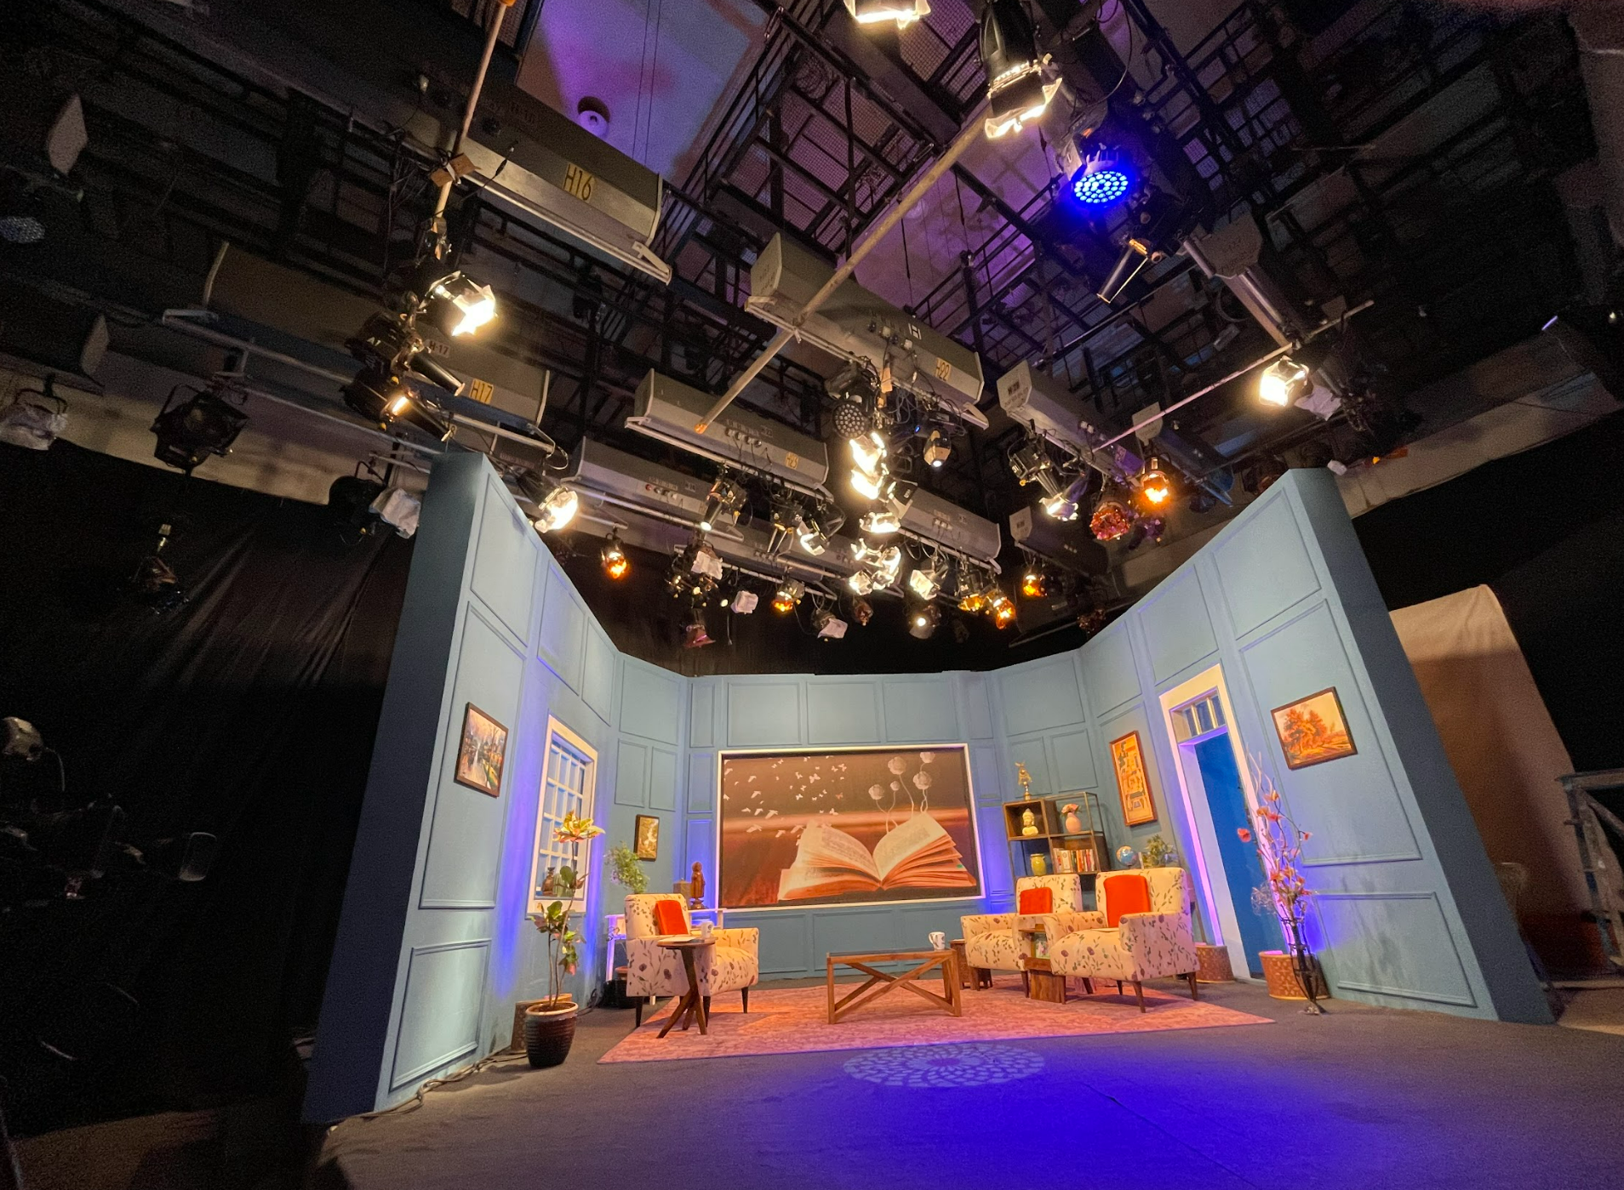

Studio A1

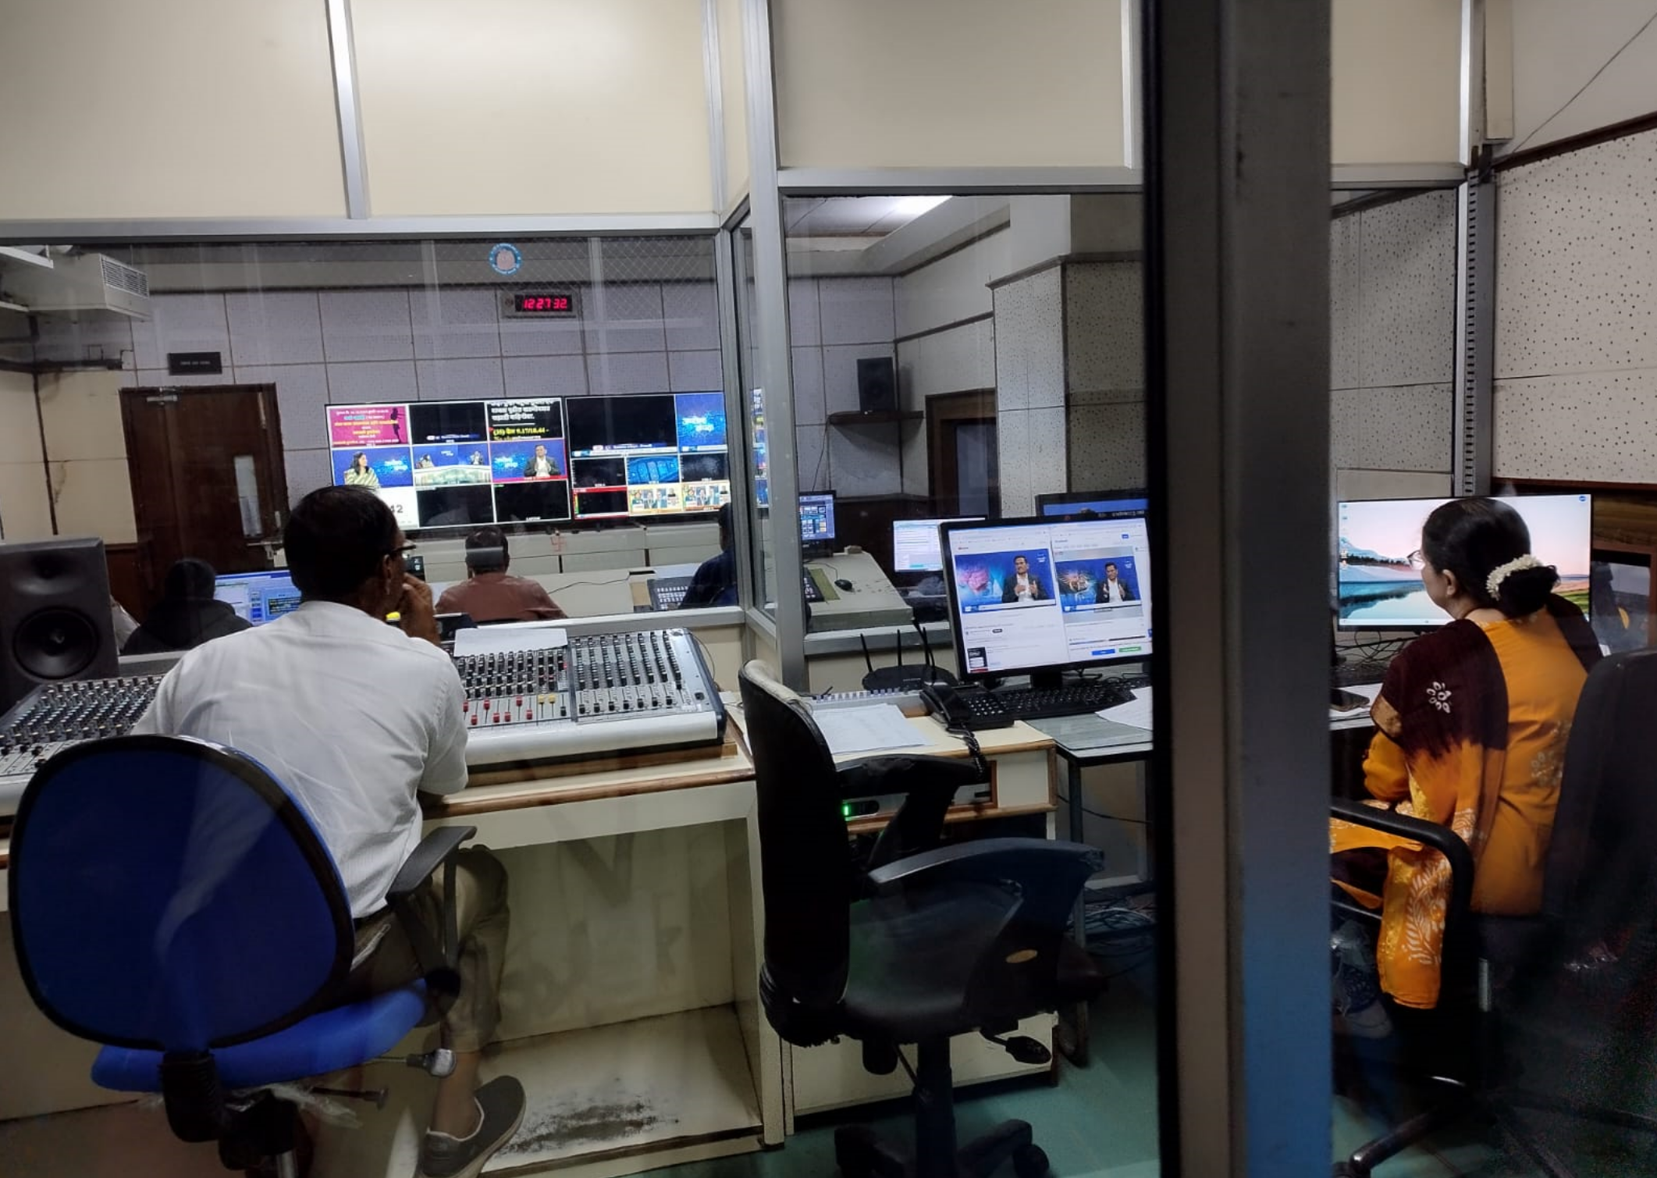

Production Control Room

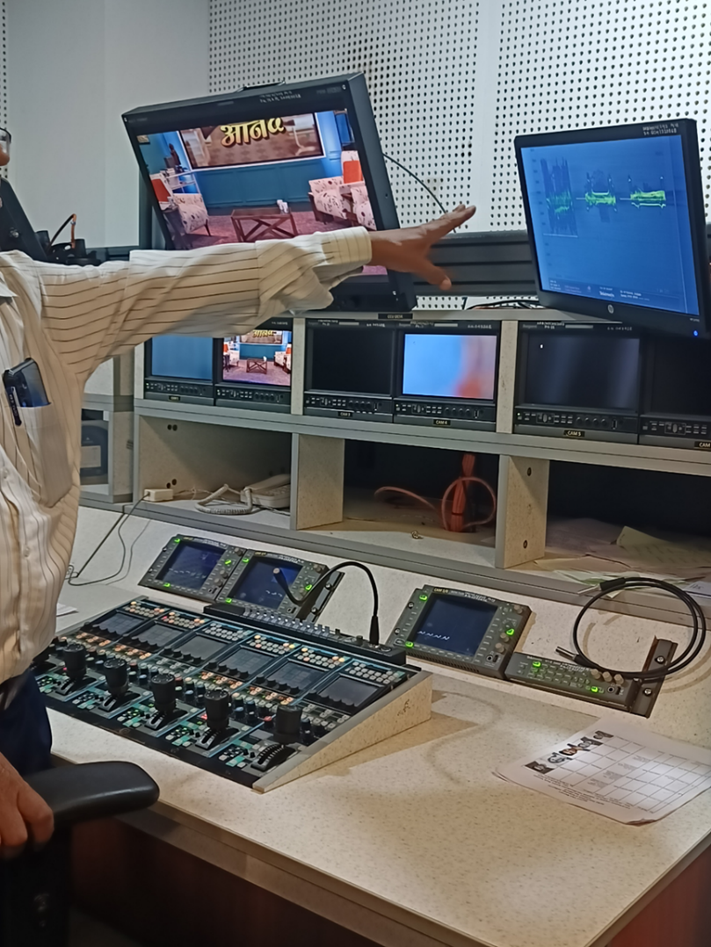

Camera Control Unit

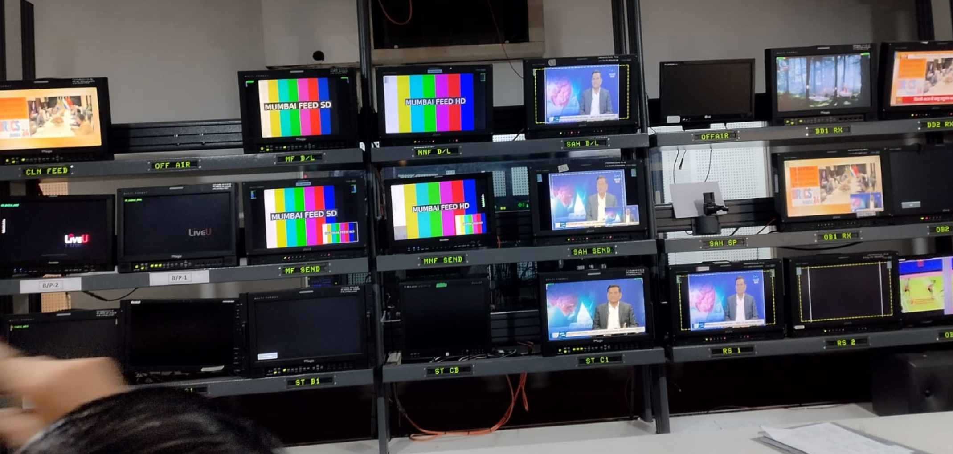

Master Switching Room

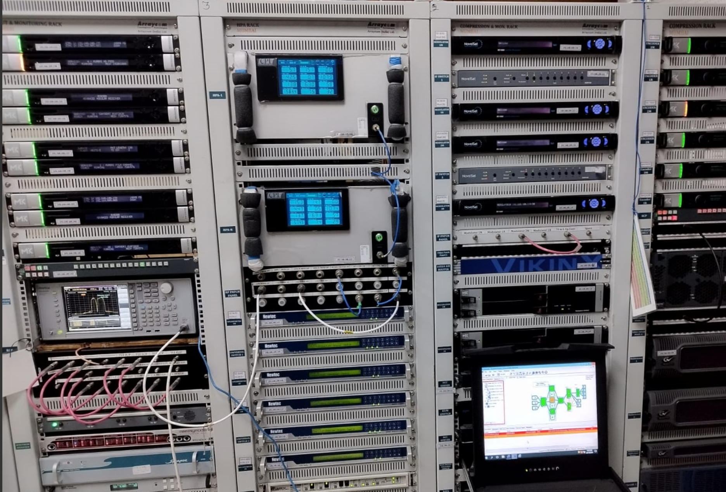

Transmission Unit

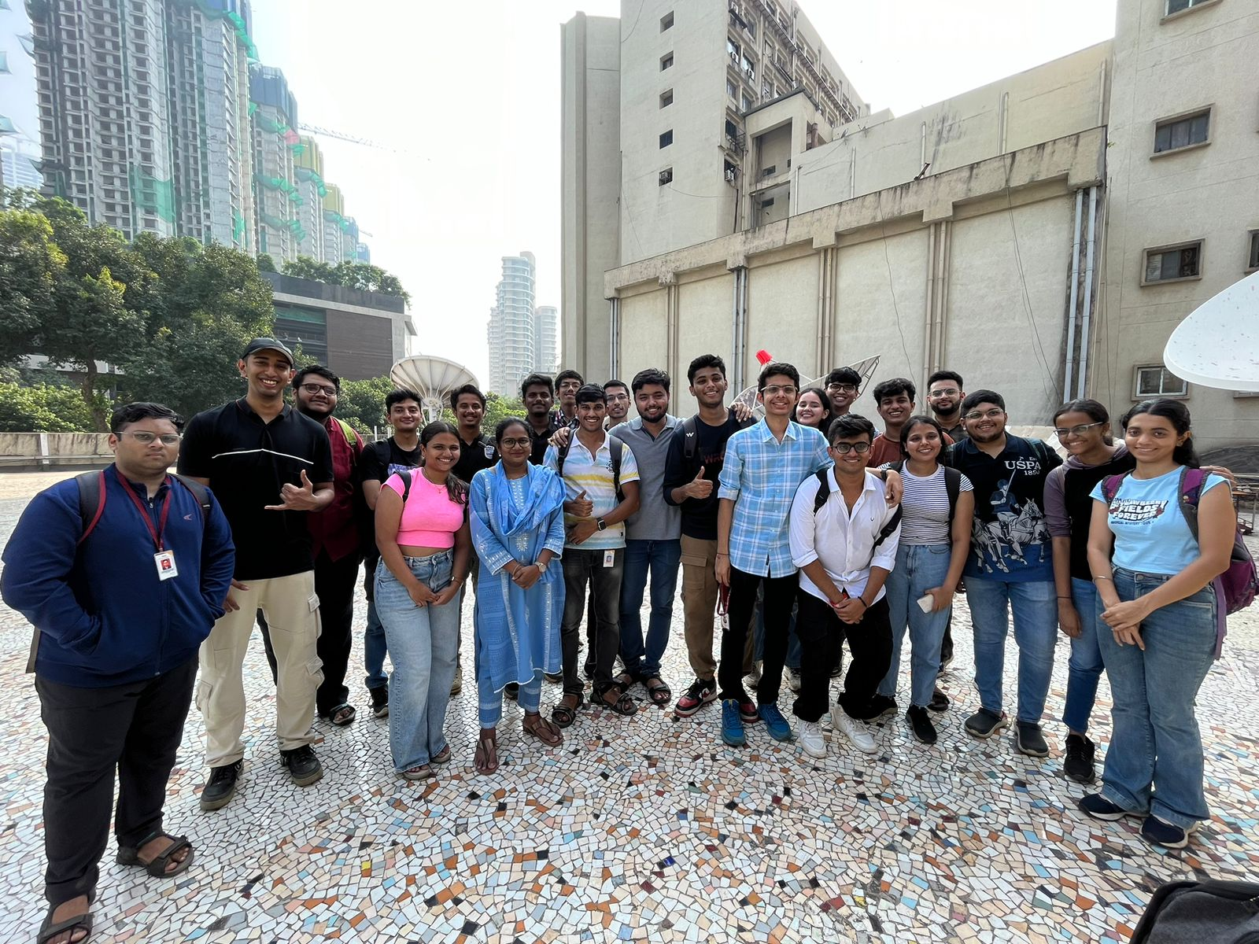

Group Photo

**Prepared By:**

Adwait Purao 2021300101

Computer Engineering Department

27/10/24